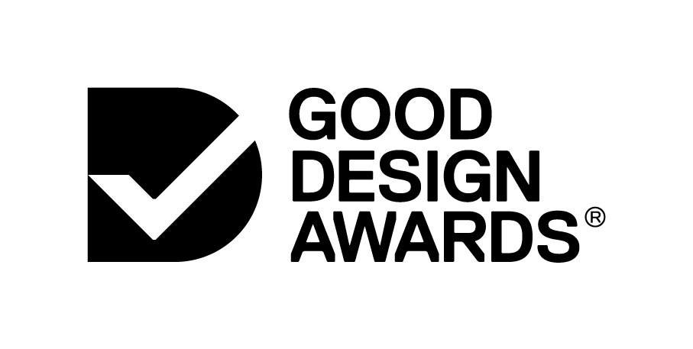
1. ENTRY TITLE
GOOD DESIGN AWARDS APPLICATION FORM PREVIEW

IMPORTANT: All Good Design Awards Entries must be submitted online at https://awards.good-design.org

2. SELECT CATEGORY

- ARCHITECTURE DESIGN
  - INTERIOR DESIGN
  - COMMERCIAL AND RESIDENTIAL ARCHITECTURE
  - URBAN DESIGN AND PUBLIC SPACES

- COMMUNICATION DESIGN
  - PRINT
  - PACKAGING DESIGN
  - BRANDING AND IDENTITY
  - ADVERTISING

- DIGITAL DESIGN
  - WEB DESIGN AND DEVELOPMENT
  - APP DESIGN
  - INTERFACE DESIGN
  - GAME DESIGN AND ANIMATION

- ENGINEERING DESIGN

- FASHION DESIGN

- NEXT GEN

- PRODUCT DESIGN
  - AUTOMOTIVE AND TRANSPORT
  - COMMERCIAL AND INDUSTRIAL
  - CONSUMER ELECTRONICS
  - DOMESTIC APPLIANCES
  - FURNITURE AND LIGHTING
  - HARDWARE AND BUILDING
  - HOUSEWARES AND OBJECTS
  - MEDICAL AND SCIENTIFIC
  - SPORT AND LIFESTYLE

- SERVICE DESIGN
  - COMMERCIAL SERVICES
  - PUBLIC SECTOR SERVICES
  - EDUCATION SERVICES

- SOCIAL IMPACT

- STRATEGY DESIGN

3. ENTRY DETAILS

Designed By:

Commissioned By:

Designed In: (Country)

Buy Online Link:

Website Link:

Twitter:

Facebook:

Instagram:

4. ENTRY INFORMATION

Entry Introduction (max. 50 words)
This will be the introduction paragraph to your entry.

Design Challenge (max. 100 words)
Please provide a brief summary that clearly and succinctly describes what challenge this project is solving i.e. What was the design brief?

Design Solution (max. 100 words)
Please describe how this project met or exceeded the brief.

Design Impact (max. 100 words)
Please describe the impact of the entry. Please refer to full criteria here. You may refer to: Social Impact, Commercial Impact, and Environmental Impact.

Other Key Features (max. 200 words)
Please list key features of the entry and any other information you would like to highlight. You may wish to refer to the full criteria here.

Select Relevant Entry Tags:
- Lifestyle & Beauty
- Home Appliances
- Furniture & Lighting
- Bedroom & Bathroom
- Hardware & Garden
- Electronics
- Built Environment
- Transport & Travel
- Commercial & Industrial
- Education
- Agriculture & Mining
- Health & Wellbeing
- Fashion & Accessories
- Sports & Outdoors
- Environment & Sustainability
- Social Good
- Services
- Government
- Entertainment & Play
- Children & Babies
- Branding & Advertising
- Work & Office

5. IMAGES AND VIDEO

IMAGES
You may upload a minimum of 3 and maximum of 8 high-resolution images to support your entry.
IMPORTANT: All images must be sized to 1230 px W x 720 px H.

- IMAGE #1 (Hero Image)
- IMAGE #2
- IMAGE #3
- IMAGE #4 (optional)
- IMAGE #5 (optional)
- IMAGE #6 (optional)
- IMAGE #7 (optional)
- IMAGE #8 (optional)

VIDEO
We recommend uploading a video link as part of your entry, if possible.
IMPORTANT: All video links must be in the form of a vimeo or youtube link, see formats below

https://www.youtube.com/watch?v=XXXXXX

https://vimeo.com/XXXXXX

6. SUPPORTING MATERIALS

Supporting Materials vary depending on the category your entry is submitted in. Please refer to the Categories and Criteria page for full details on requirements for your specific category.

7. ADDITIONAL ACCOLADES

Good Design Australia also presents a number of other accolades in association with Industry Partners. Please select the Accolades you wish your entry to be considered for below.

☐
202020 Vision Green Design Award (optional)
The 202020 Vision Green Design Award recognises excellence in green urban and space design. The Award was established by Good Design Australia and the 202020 Vision to help raise awareness and to promote excellence in green design.

☐
CSIRO Design Innovation Award (optional)
The CSIRO Design Innovation Award recognises the important role of design-led innovation in harnessing the challenges of science and technology to create better products and services that make a positive impact on our lives.

☐
MAAS Award (optional)
The Museum of Applied Arts and Sciences Award is given to a project that has potential to make a significant improvement to the quality of health, wellbeing or the environment.
This Award recognises the important role of design in harnessing the challenges of science and technology to make a positive impact on our lives.

☐
Safe Work Australia Award (optional)
The Safe Work Australia Award recognises the importance of good design in improving work health and safety practices. Additional questions for this award are below.
- Safety in Construction, Use and Maintenance (max. 100 words)
- Safety Innovation (max. 100 words)
- Sustainability (max. 100 words)
- Health and Safety Impact (max. 100 words)

☐
Indigenous Designer Award (optional)
If you would like to be considered for the Indigenous Designer Award, and identify as Aboriginal or Torres Strait Islander Australian, then please tick here.

8. APPLICANT INFORMATION

First Name:

Last Name:

Job Title:

Company Name:

Email Address:

Work Phone:

Mobile Phone:

Address:

Suburb:

State:

Postcode:

Country:

Company Size:
Please select your Company Size.

- Start-up (1 employee)
- Small (2-4 employees)
- Medium (5-19 employees)
- Large (20-99 employees)
- Enterprise (100-500+ employees)

9. CONFIRMATIONS

☐
I confirm this entry meets the requirements for entry and is eligible to enter the Good Design Awards.
View Full Eligibility Criteria here.

☐
I understand that the Good Design Awards requires a registration fee to enter.
Entry to the Next Gen category is Free of Charge.
Entry to the Social Impact category is $150 + GST.
Entry to all other categories is $450 + GST.
(All registration fees are subject to an additional 1.5% surcharge for credit card users and +3% for AMEX users).

☐
Good Design Award® Winners will be automatically included in the Winners Package, at an additional cost. Please confirm if you are happy to be automatically included.
View Winners Package Fees and Inclusions here.

☐
I agree to the Terms and Conditions of Entry to the Good Design Awards.
View Terms and Conditions here.

END

